Task 1: What do you understand by Big-O notation
Big – O notation is an asymptotic notation which is used to describe the worst case scenario of the algorithm

Task2: What are arrays? How many types of array are there?
Arrays are the homogeneous data structures which stores the data in a contiguous order
Arrays can be classified in terms of dimensions as 1D, 2D & multi-dimensional array

Task 3: What do you understand by strings in java?
Strings are immutable data structures in java which stores the array of characters in a contiguous memory block and ends with `\0` (null character)

Task 4: Create array in java
import java.util.*;

class Main {

public static void main(String[] args) {
int arr[] = {1,2,3,4,5};

for(int ele:arr){
System.out.println(ele);
}
}

}

Task 5: Print the string in reverse order
import java.util.*;

class Main{
public static void main(String [] args){
Scanner scan = new Scanner(System.in);

System.out.print("Enter the string: ");

String str;
str = scan.nextLine();

for(int i=str.length()-1;i>=0;i--){
System.out.print(str.charAt(i) + " ");
}

scan.close();
}
}

Task 6: Write a program to show difference between static & instance variable
import java.util.*;

class Main{
int instanceVar = 0;
static int staticVar = 0;

public static void main(String [] args){
Main obj1 = new Main();

obj1.increaseStaticVar();
obj1.increaseInstanceVar();

obj1.printInstanceVar();
obj1.printStaticVar();

Main obj2 = new Main();
obj2.increaseInstanceVar();
obj2.increaseStaticVar();

obj2.printInstanceVar();
obj2.printStaticVar();
}

public void increaseInstanceVar(){
this.instanceVar++;
}

public static void increaseStaticVar(){
staticVar++;
}

public static void printStaticVar(){
System.out.println("Static: "+staticVar);
}

public void printInstanceVar(){
System.out.println("Instance:" + this.hashCode() + " " +instanceVar );
}
}

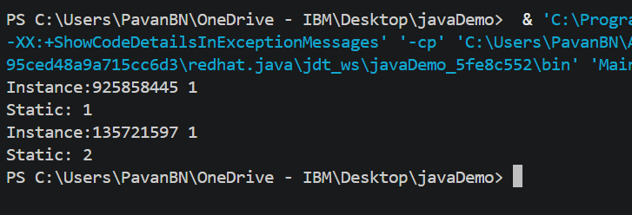
Task 7: Way to print numbers from 100 to 10
import java.util.*;

class Main {

public static void main(String[] args) {
for (int i = 100; i >= 10; i--) {
System.out.print(i + " ");
}
}

}

Task 8: Way to accpe login id & pwd from user & display welcome msg if credential matches? Use while loop
import java.util.*;

class Main {

public static void main(String[] args) {
Scanner scan = new Scanner(System.in);

while (true) {
System.out.println("Enter username: ");
String username = scan.next();

System.out.println("Enter password");
String password = scan.next();

if (username.equalsIgnoreCase("pavan") && password.equals("123")) {
System.out.println("Welcome Pavan");
break;
} else {
System.out.println("Invalid credentials");
}
}

scan.close();
}

}

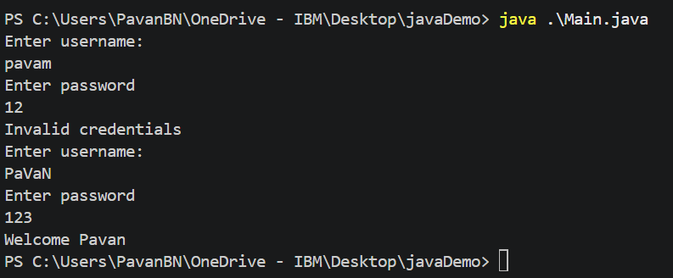

Task 9: Way to accept id & pwd & display welcome msg on successful login, use do-while loop?
import java.util.*;

class Main {

public static void main(String[] args) {
Scanner scan = new Scanner(System.in);

do {
System.out.println("Enter username: ");
String username = scan.next();

System.out.println("Enter password");
String password = scan.next();

if (username.equalsIgnoreCase("pavan") && password.equals("123")) {
System.out.println("Welcome Pavan");
break;
} else {
System.out.println("Invalid credentials");
}
} while (true);

scan.close();
}

}

Task 10: way to display the use of if-else ladder , nested if
import java.util.*;

class Main {

public static void main(String[] args) {
Scanner scan = new Scanner(System.in);

System.out.print("Enter Marks: ");
int marks = scan.nextInt();

if (marks > 0 && marks < 35) {
System.out.println("Fail!");
} else if (marks > 35 && marks < 60) {
System.out.println("Just Pass class");
} else if (marks >= 60 && marks < 80) {
System.out.println("First Class");
} else {
if (marks >= 80 && marks < 90) {
System.out.println("Distinction");
} else {
System.out.println("Topper");
}
}

scan.close();
}

}

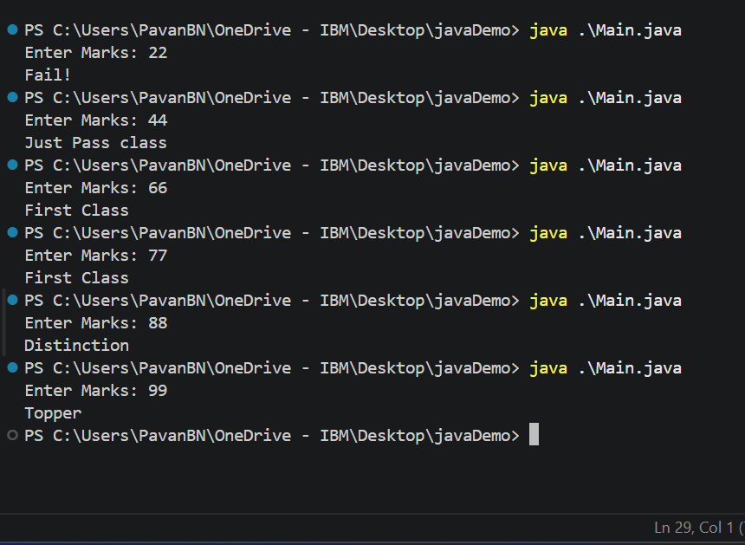

Task 11: Way to display the use of switch case?
import java.util.*;

class Main {

public static void main(String[] args) {
enum Shape {
TRIANGLE,
RECTANGLE
}

switch (Shape.RECTANGLE) {
case RECTANGLE:
System.out.println("Its rectangle");
break;

case TRIANGLE:
System.out.println("Its Triangle");
break;
default:
System.out.println("Invalid Shape");
break;
}
}

}

Task 12: what are access modifiers in java?
Access modifiers in java controls the visibility of properties or methods to provide a security & allow to control how data is shared among the classes & packages

Task 13: Wap to accept customer names and display them using enhanced for loop
import java.util.*;

class Main {

public static void main(String[] args) {
Scanner scan = new Scanner(System.in);

List<String> list = new ArrayList<>();

System.out.println("How many data you wants to insert: ");
int n = scan.nextInt();

while(n>0){
String name = scan.next();
list.add(name);
n--;
}

for(String name:list){
System.out.println(name);
}
}

}

Task 14: Wap to show the difference between continue and break;
import java.util.*;

class Main {

public static void main(String[] args) {
System.out.println("Print Odd Number from 1 & break if i divisable by 5");
for(int i=1;;i++){
if(i%2==0) continue;
if(i%5==0) break;
System.out.print(i+" ");
}
}

}

Task 15: Create Manager -> Employee class which shows the inheritance relationship.

import java.util.*;

class Main {

public static void main(String[] args) {
Manager manager = new Manager(22);
manager.printAge();
}

}

class Employee {
int age;

public Employee(int age) {
this.age = age;
}

public int getAge() {
return age;
}
}

class Manager extends Employee {
public Manager(int age) {
super(age);
}

public void printAge() {
System.out.println(super.getAge());
}
}

Multi-Level Inheritance
import java.util.*;

class Main {

public static void main(String[] args) {
Manager obj = new Manager();
obj.print();
}
}

class Person1 {
public void print() {
System.out.println("Person1");
}
}

class Employee extends Person1 {
public void print() {
System.out.println("Employee");
}
}

class Manager extends Employee {
int id = 20;
public void print() {
System.out.println("Manager");
}
}

